How to Set Up Google Analytics

Set up Google Analytics: The Global Website Tag

Step 1: Create a Google Analytics account
Go to Analytics: Create an account or sign in to Analytics
Click the "Start for free" button.


Step 2: Enter the welcome page
After creating an account or signing in, you are welcomed to the solution.
Press the "Start measuring" button to proceed.


Step 3: Account setup
You have two decisions to make here.
- Enter your account name.
- Decide what data you want to share.
- Click the "Next" button.
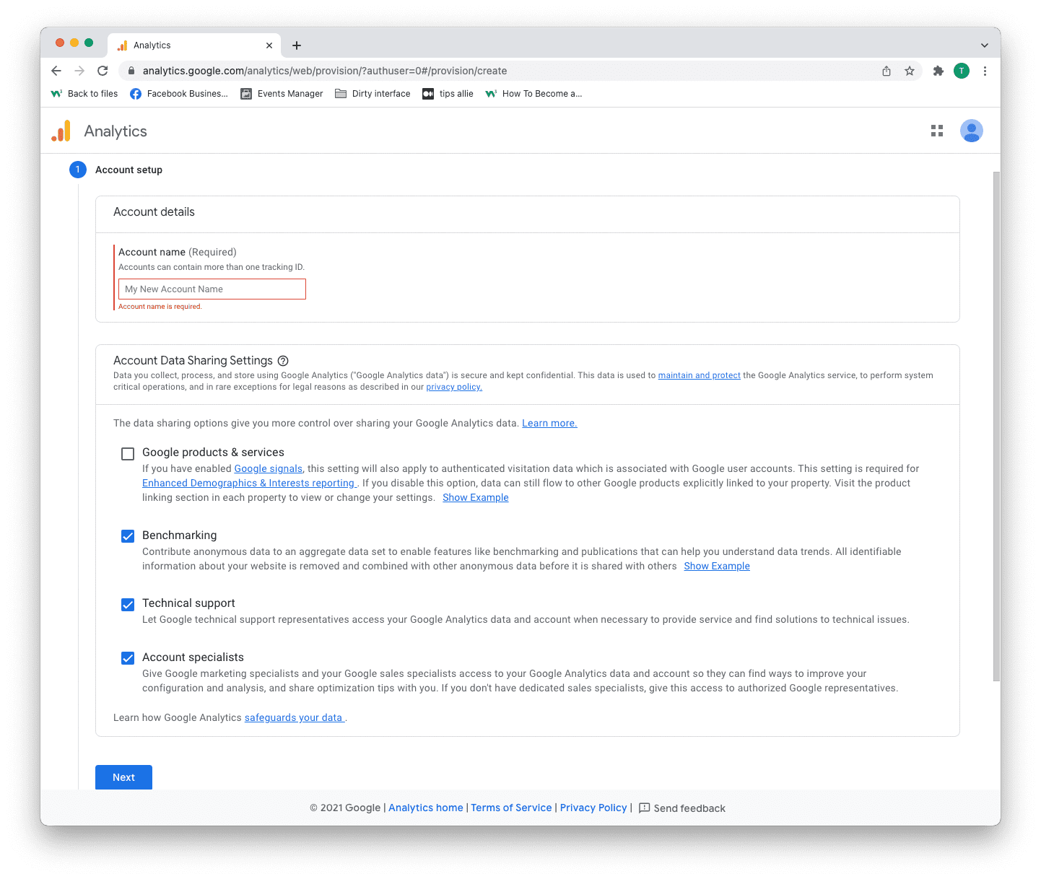

Step 4: Property setup
- Enter a property name.
- Enter your time zone.
- Enter the currency that you use.
- Click the "Next" button.
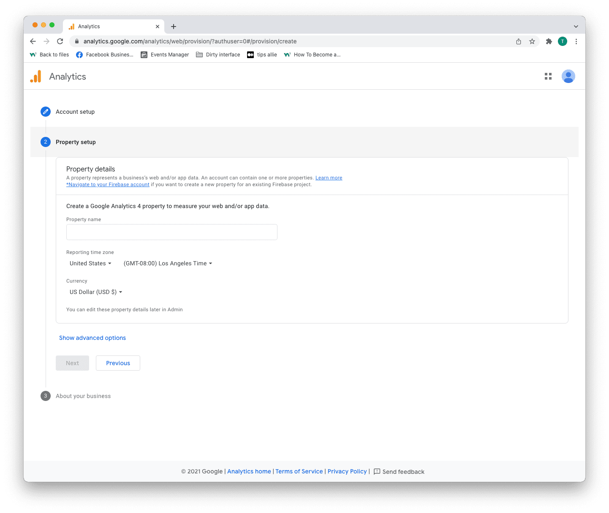

Step 5: Add business information
- Select your industry category.
- Select business size.
- Tick the boxes for how you are planning to use Analytics.
- Click the "Create" button to proceed.
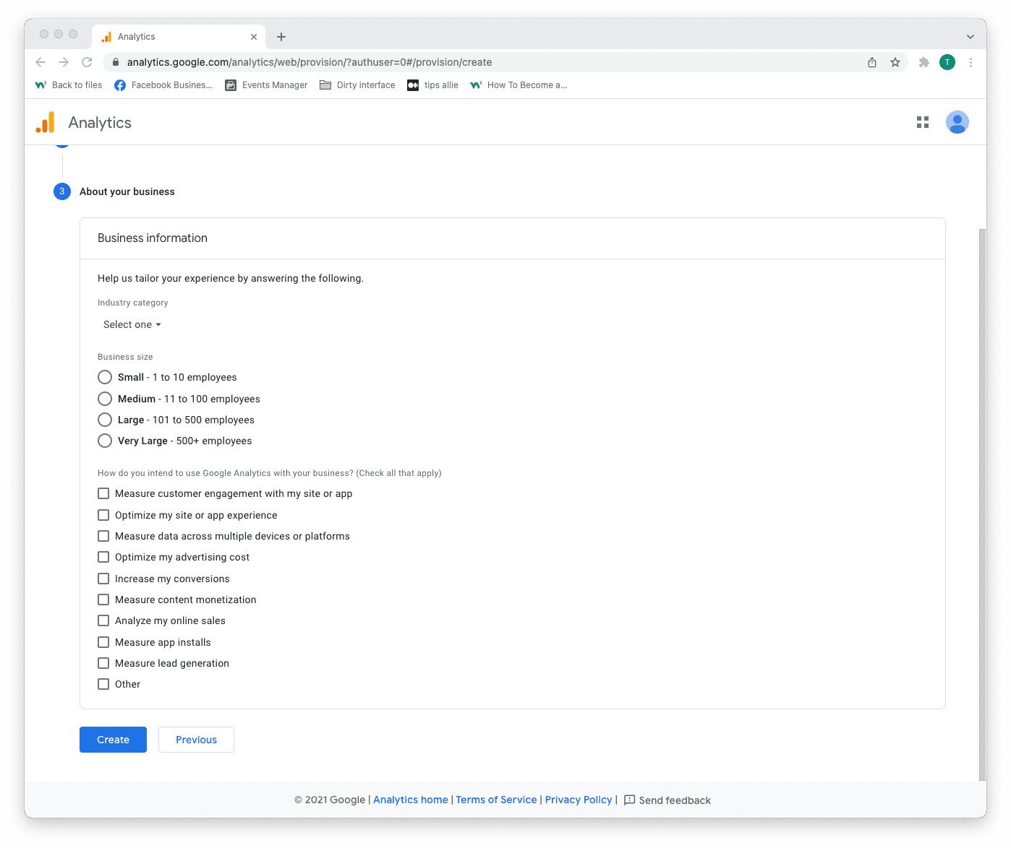

Step 6: Terms of Service Agreement
Read and understand the terms of service.
Tick the GDPR box and click the "I accept" button if you agree.
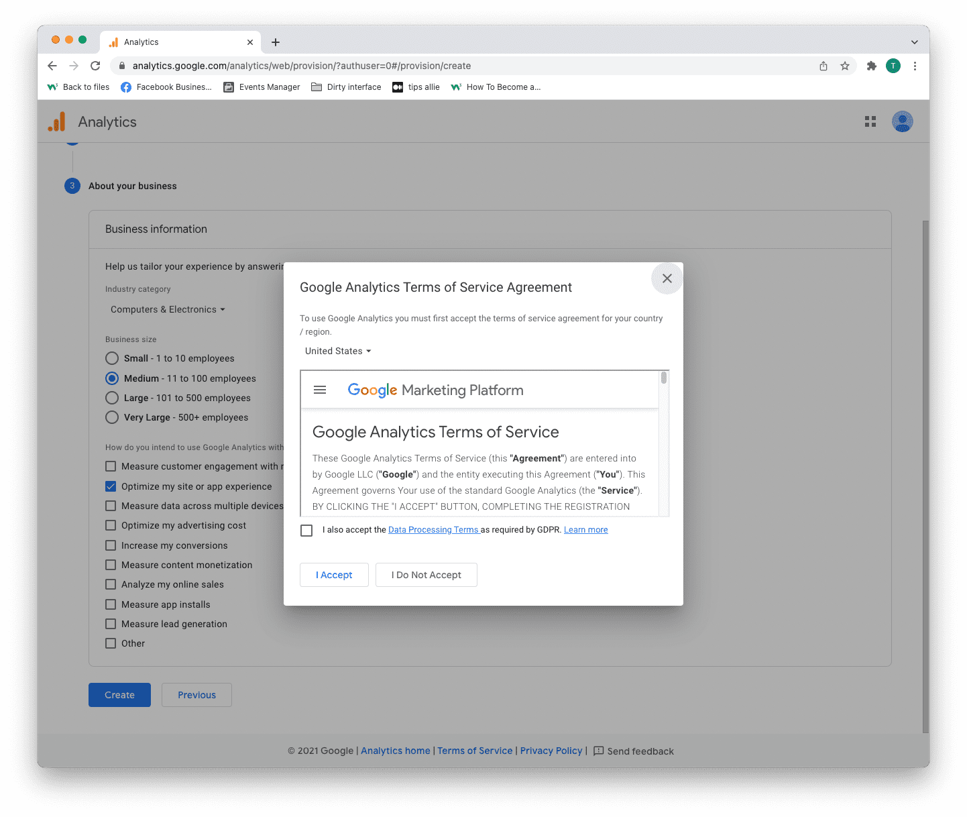

Step 7: Email subscriptions
- Tick or uncheck all boxes.
- Click the "Save" button to continue.
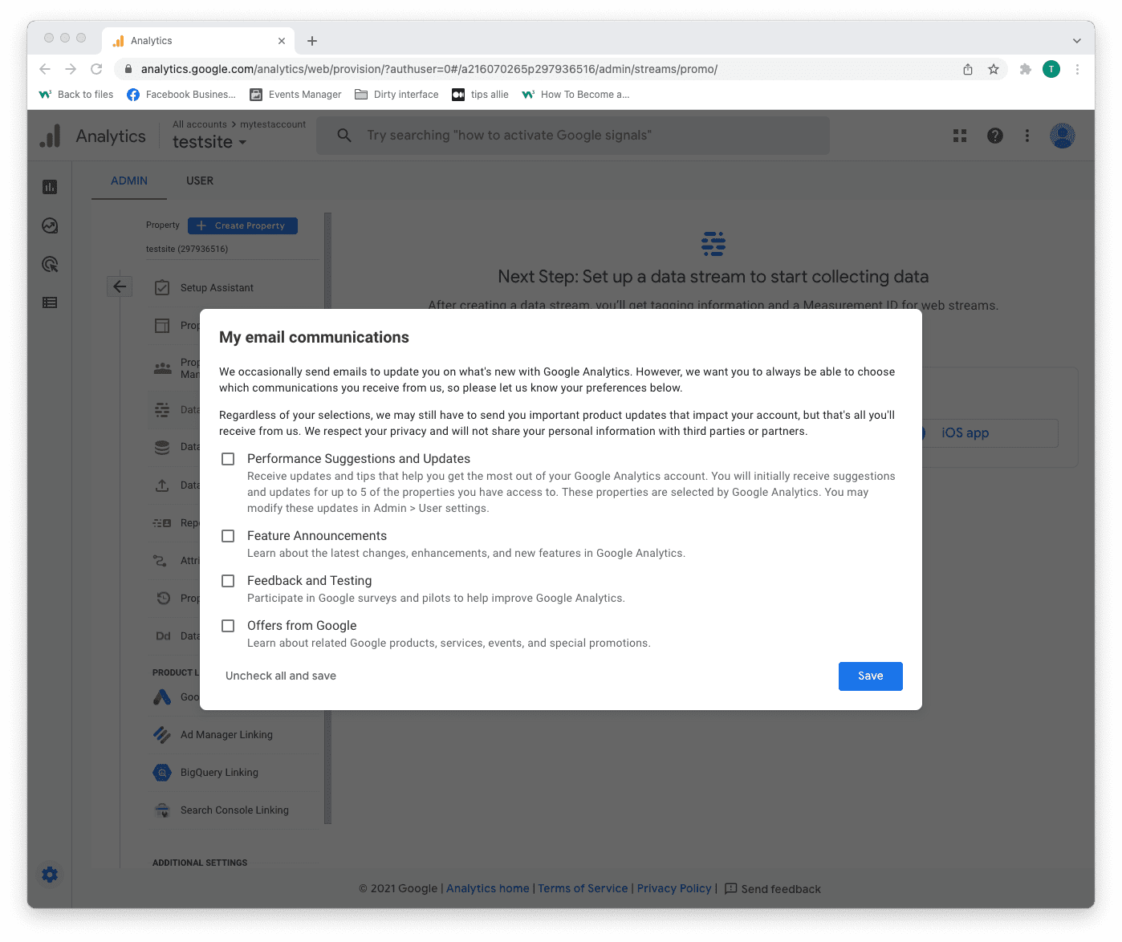

Step 8: Select platform
Choose the platform where you are collecting data.
Then, click the relevant platform to continue.
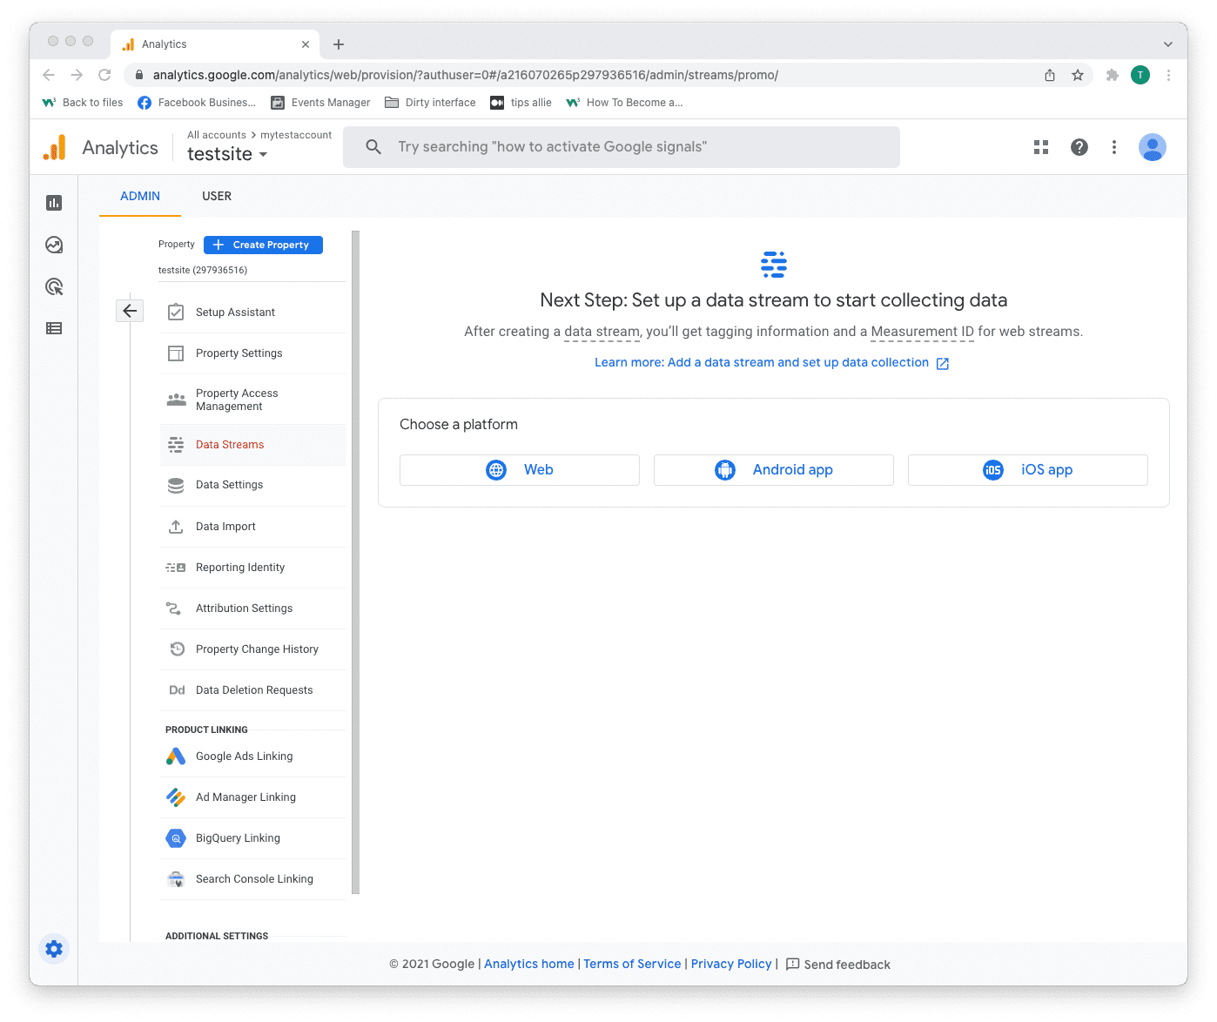

Step 9: Data stream setup
Enter data stream details.
- The URL to your site.
- The name that you want to give the stream.
- Decide if you are to enable enhanced measurement or not.
- Click on the "Create stream" button to continue.
The enhanced measurement can give the data more context. Improving your understanding of the traffic.
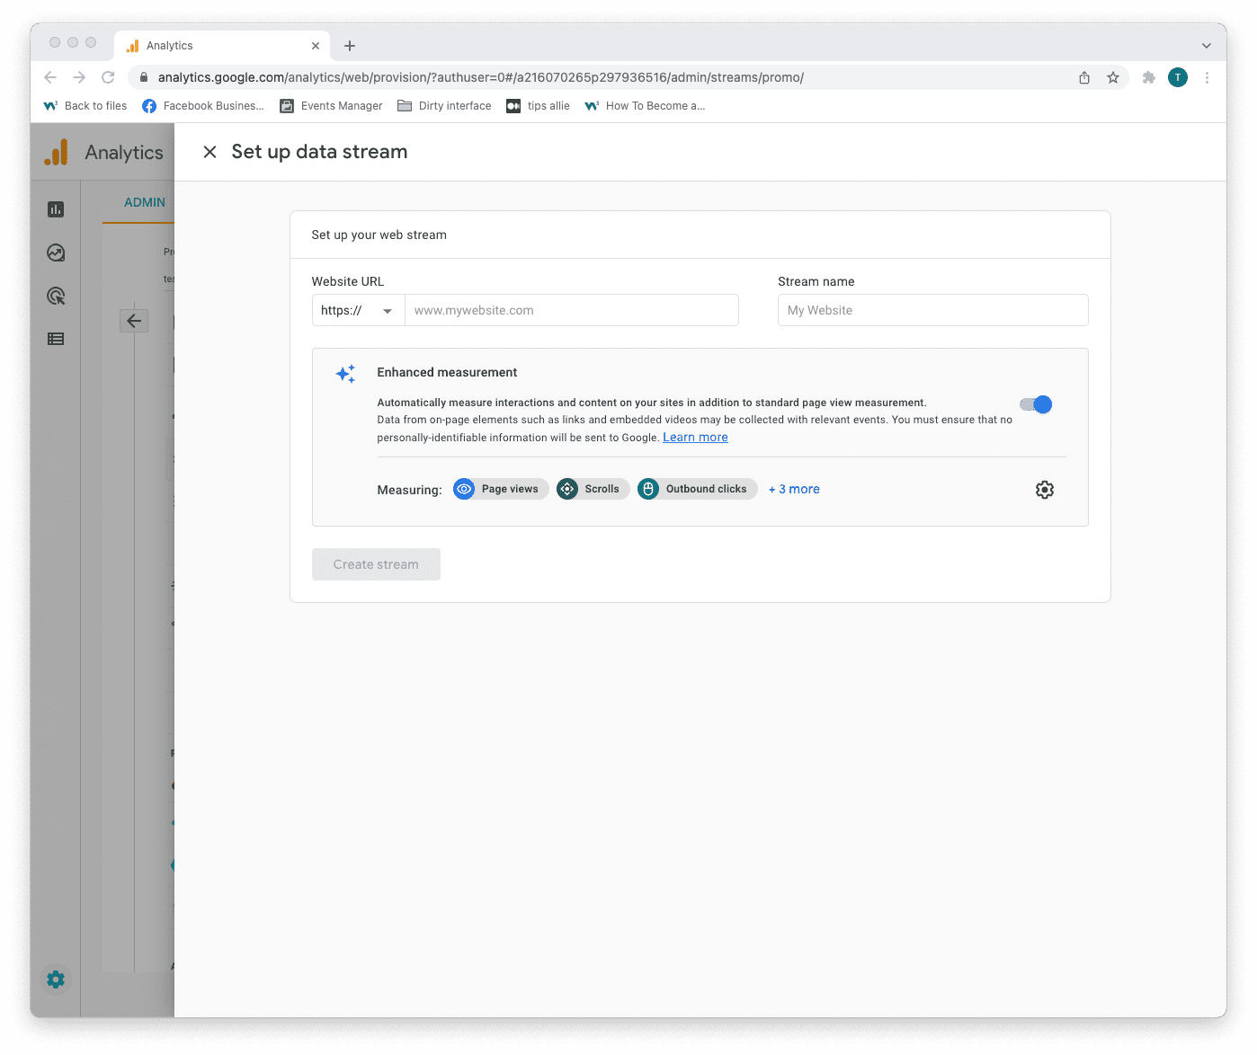
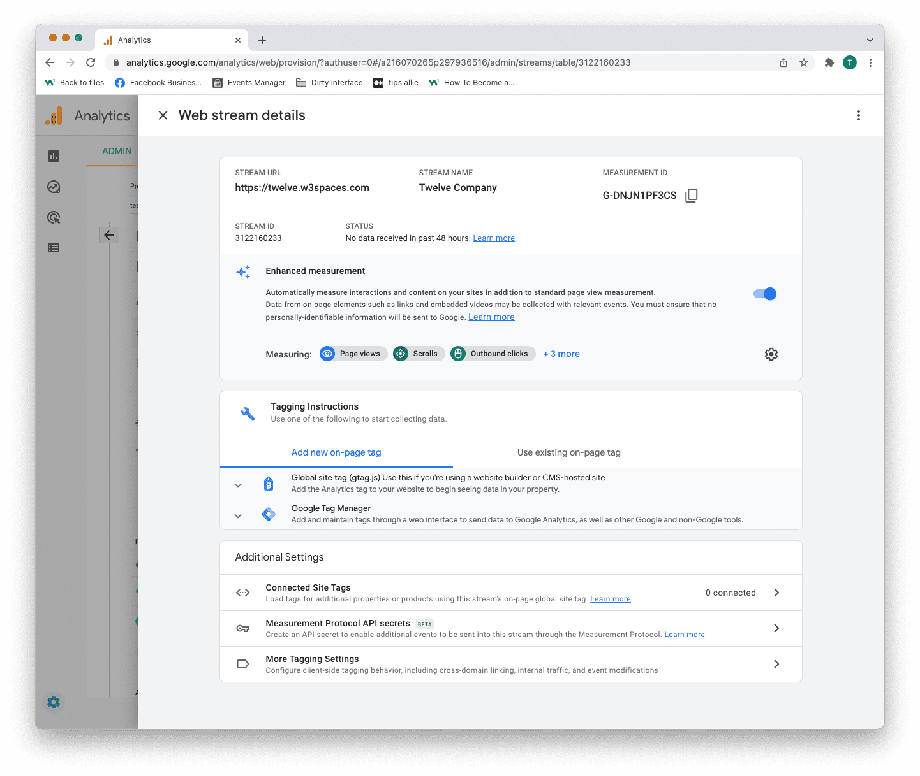

Step 10: Web stream overview
Here you can see a detailed overview of the web stream.
Here are the key takeaways from the overview.
1. Stream URL.
The Stream URL is the link to the connected site.
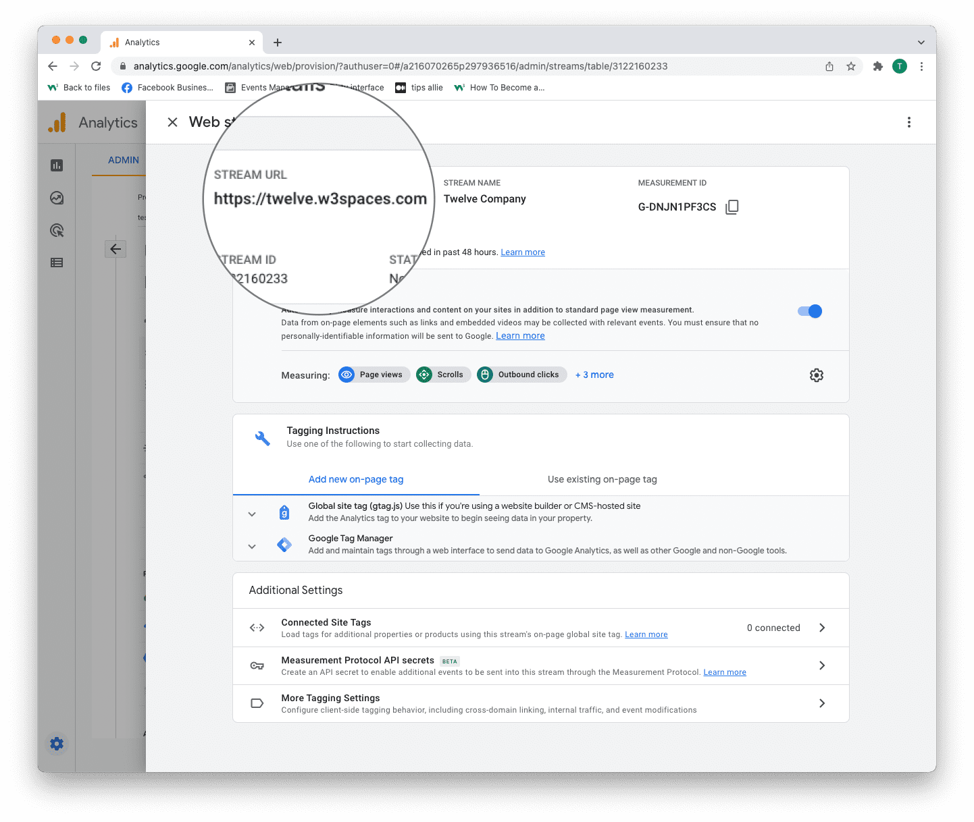

2. Measurement ID
The Measurement ID is the identifier for your data stream.
It has a format of G-XXXXXXX.
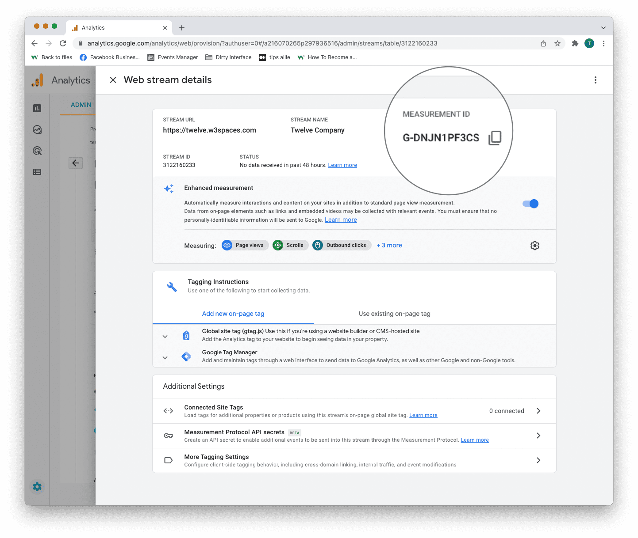

3. Tagging instructions
Decide to use Global site tag (gtag.js) or Tag manager.
This tutorial will use the Global site tag.
Installing the Global site tag is the easiest and quickest way of getting it up and running.
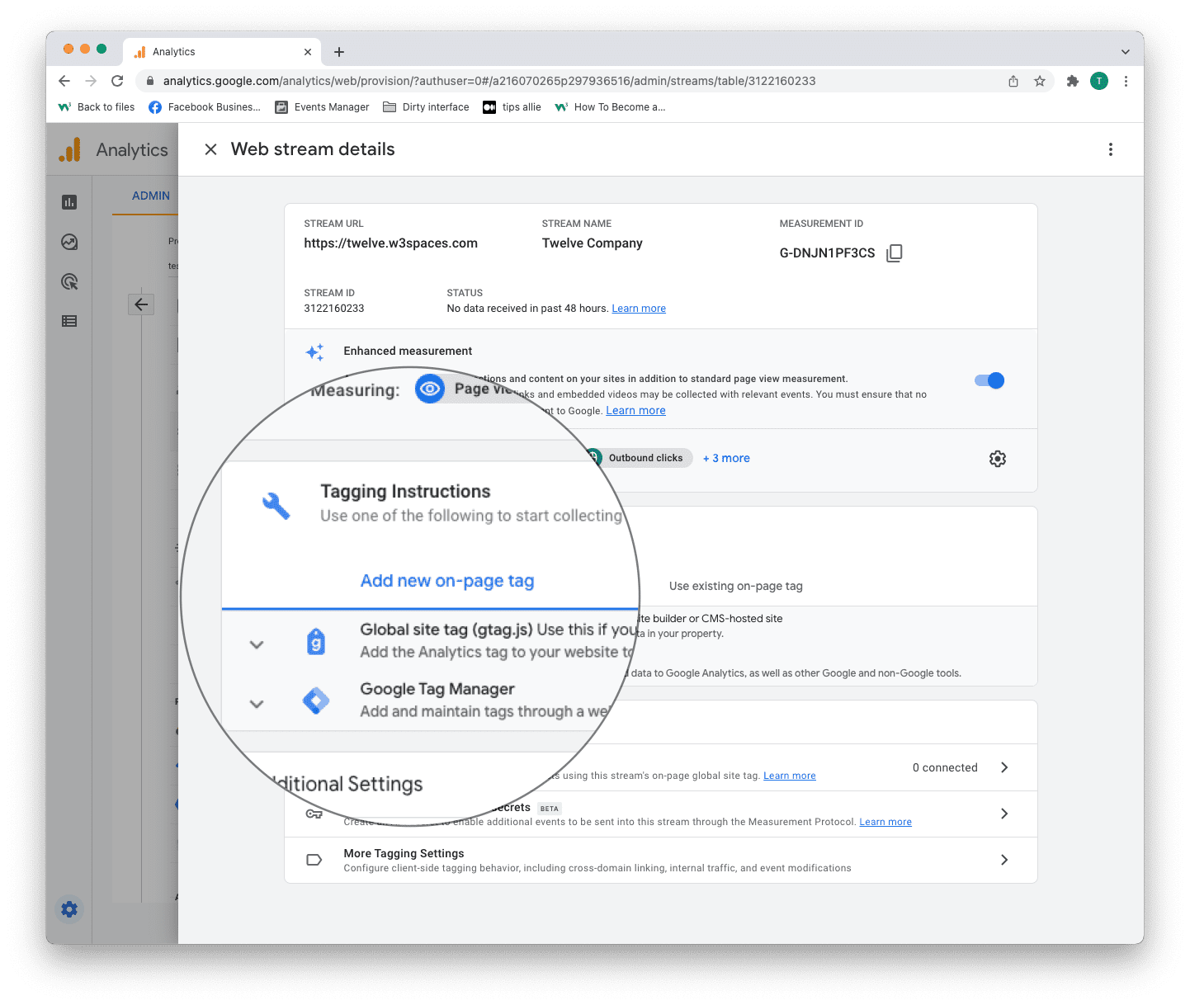

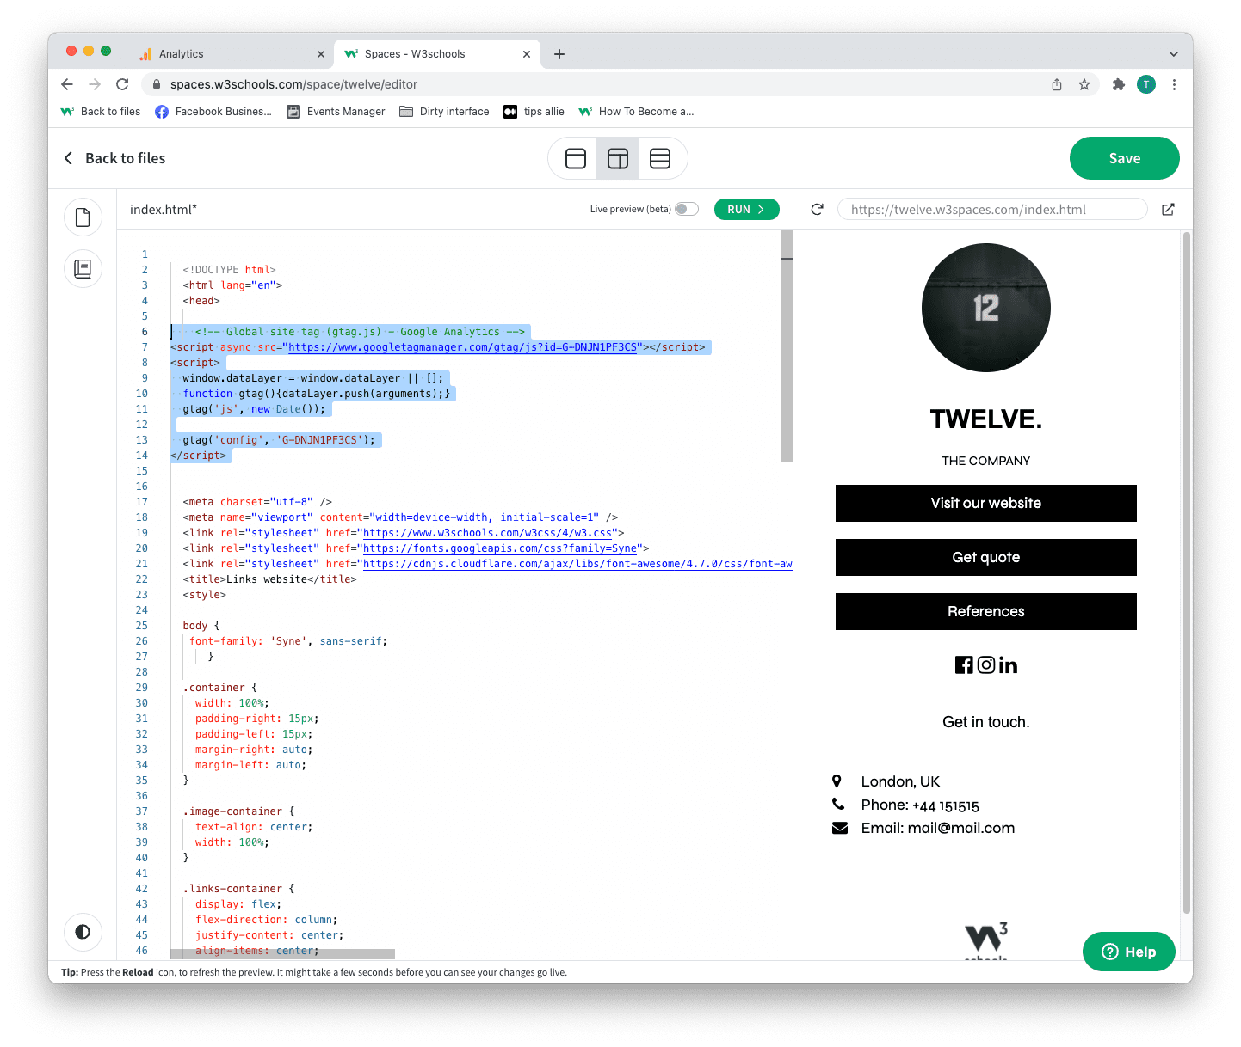
Step 11: Global site tag (gtag.js)
Click the "Global site tag (gtag.js)" row.
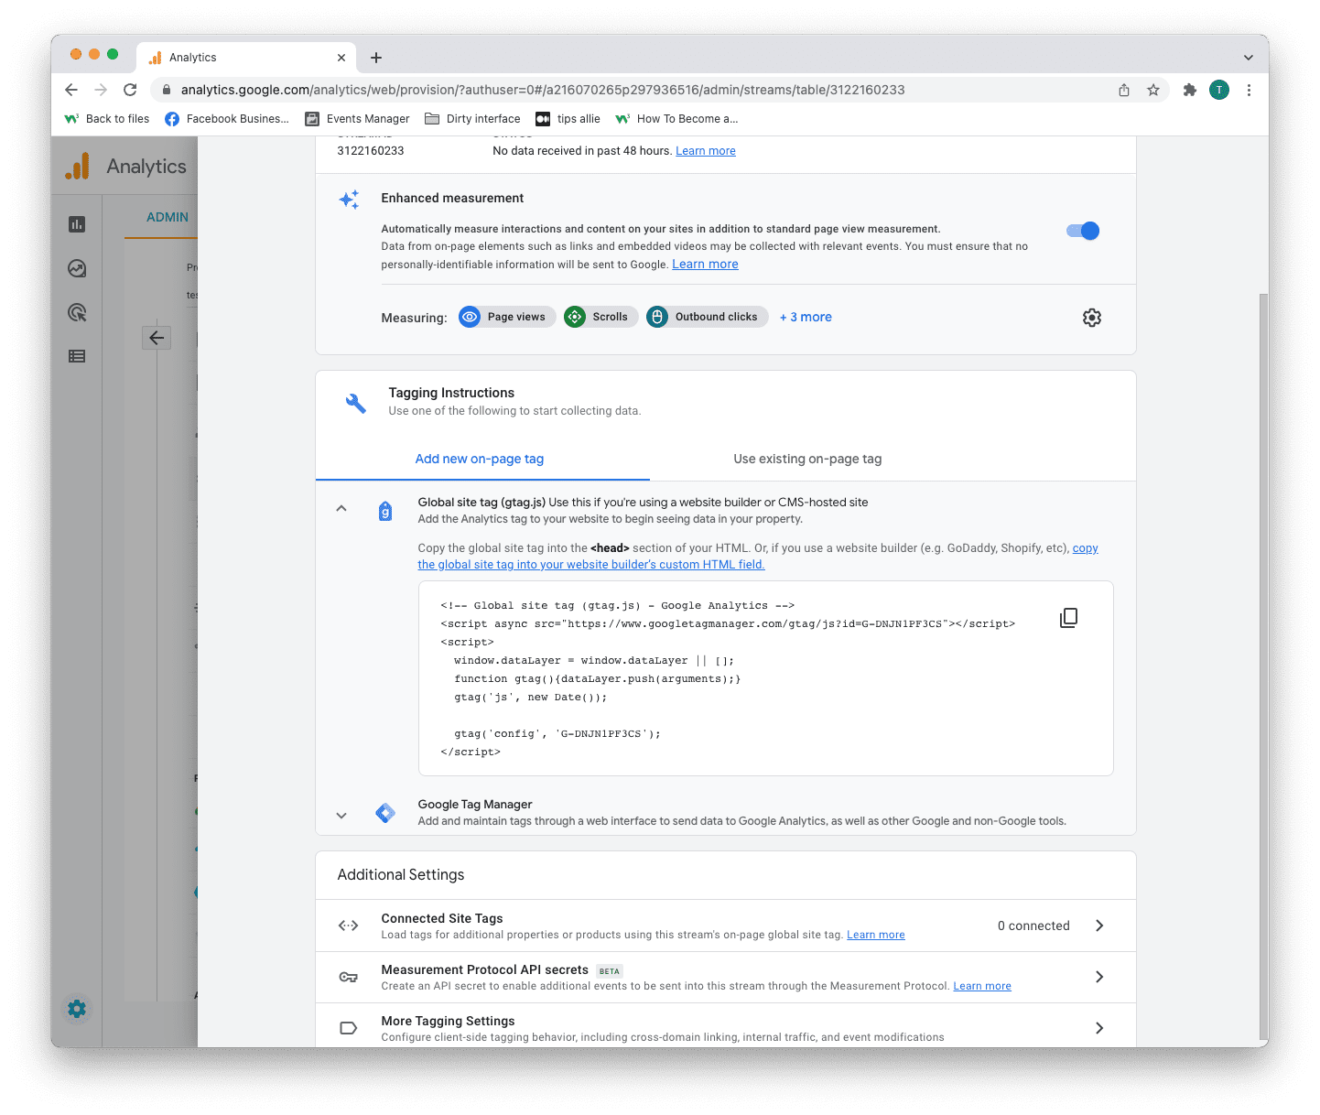
Here you can see a code snippet.
The code snippet is a script to allow Google to measure data on your site.
You can see the Measurement ID in the second last line in the code snippet.
The code snippet
<!-- Global site tag (gtag.js) - Google Analytics -->
<script async src="https://www.googletagmanager.com/gtag/js?id=G-DNJN1PF3CS"></script>
<script>
window.dataLayer = window.dataLayer || [];
function gtag(){dataLayer.push(arguments);}
gtag('js', new Date());
gtag('config', 'G-XXXXXXX');
</script>
Step 12: Enter the code snippet
Copy the code snippet.
Make sure to include your Measurement ID.
Locate the <head> tag in your HTML.
Paste the code snippet just below the <head> tag.
Save and publish the code.

Step 13: Test that it works
Ensure that you have successfully saved and published the code snippet with the correct Measurement ID.
Open the URL for the site you have connected to the data stream.
Click on "Real time" on the menu to the left.
Confirm that you see yourself as an active user.
Congrats. You have successfully enabled Google Analytics for your site!
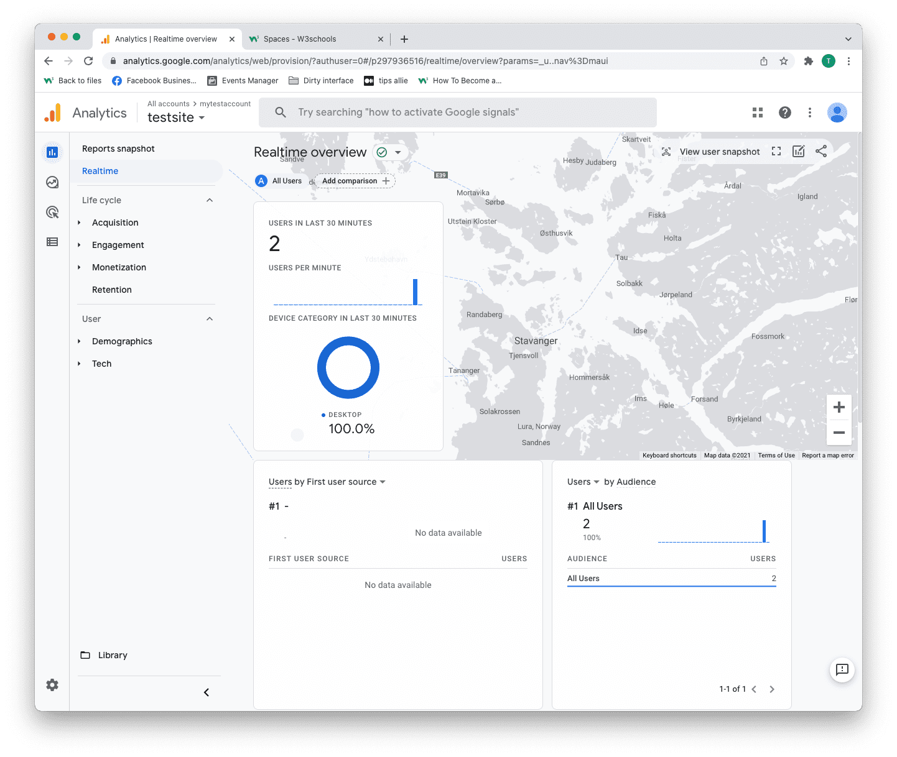

How to give access at the account level
Note: Only administrators can add someone or give access.
Step 1: Log in to your Google Analytics account.
Step 2: Click on the "Admin" icon at the bottom of the left-hand menu.
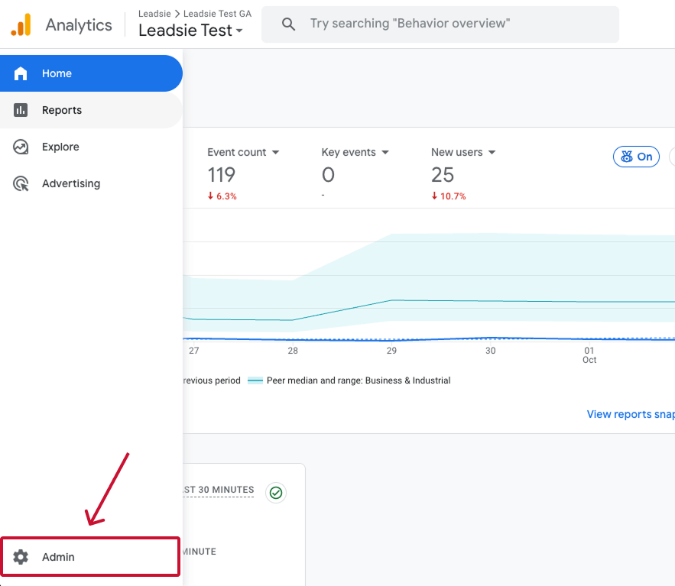

Step 3: Under Account, click on “Account Access Management.”
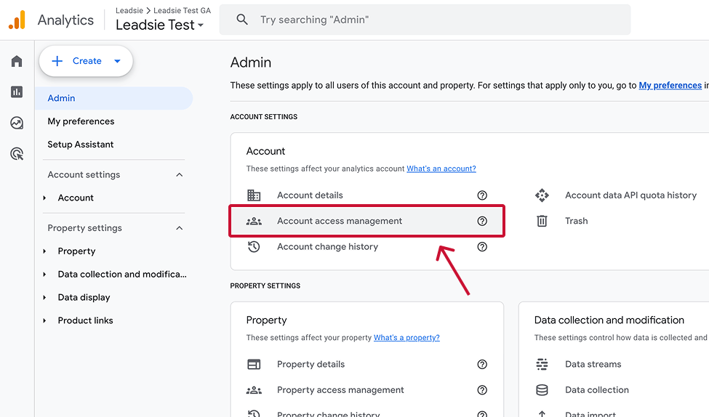
Step 4: In the top right corner, click the “+” icon, then select "Add users."
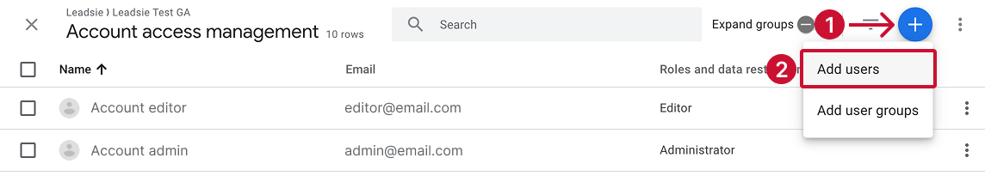
Note: If you’re managing multiple users or teams, you’ll also see an option here to add user groups too (we’ll explain this below).
Step 5: Enter the email address of the user you want to add. This can be a standard Gmail address or one linked to a Google Workspace.

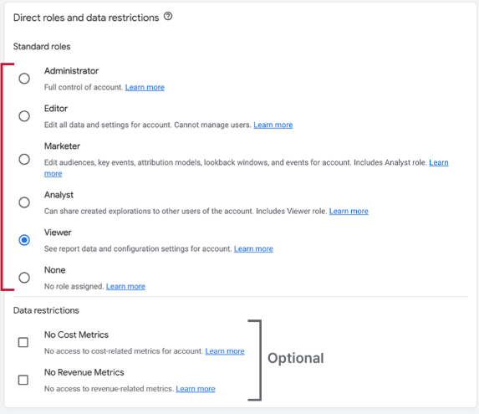

Step 6: Select a role (like Viewer, Editor, or Admin), and click “Add” in the top right corner to send them an invite.
Step 7: Have the invite check their inbox and accept the invitation in the email.

